St Joseph’s Newsletter



10/10/2025

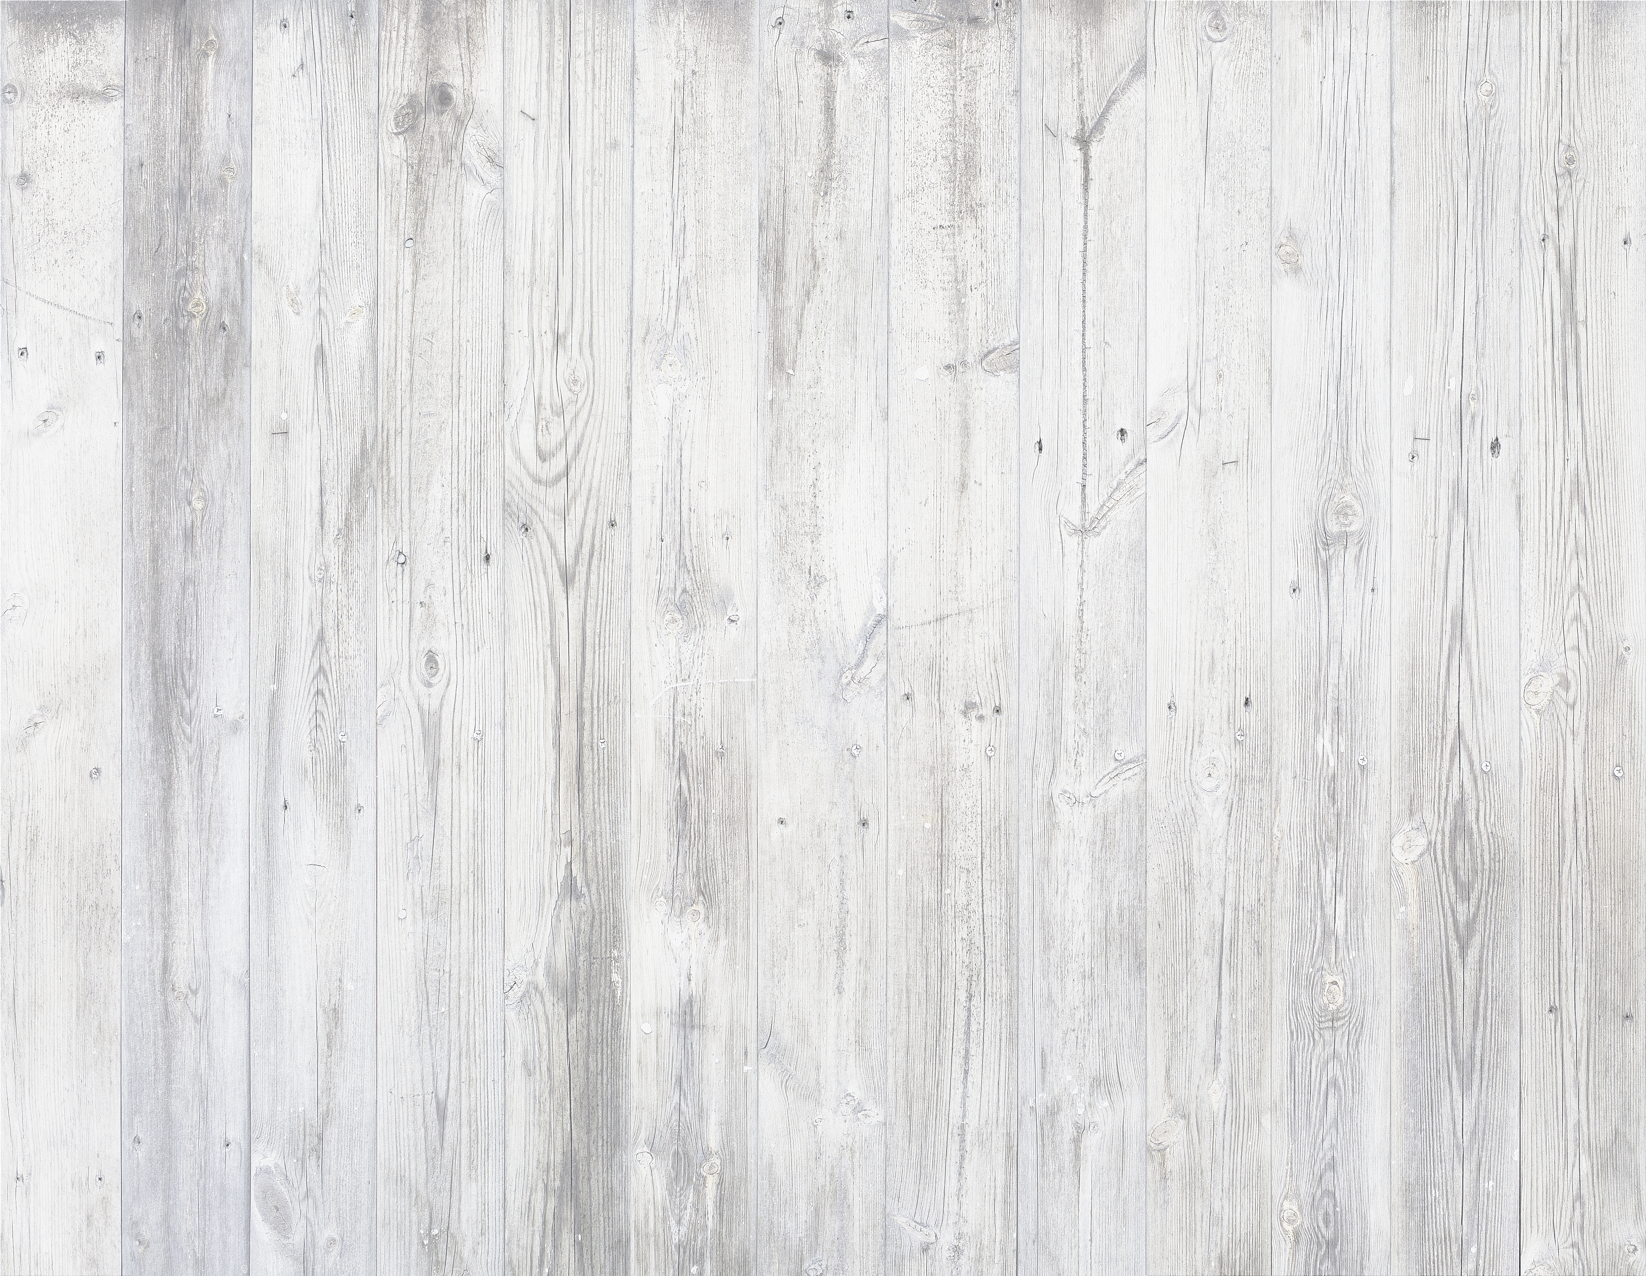

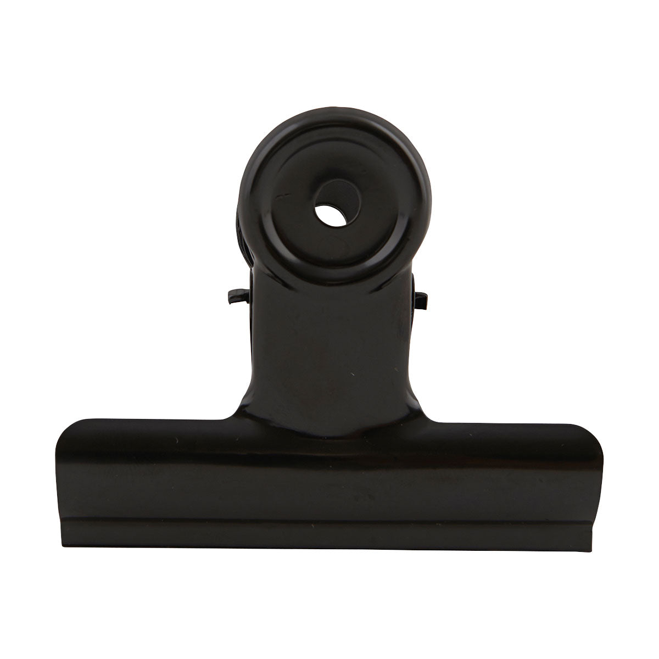
The parent workshops in EYFS and Year 1 were well attended, thank you. We hope that you found them useful.

Photos, individual and with siblings will be taken on Monday 13th October. Please make sure that children are in their full school uniform. If your child has PE on Monday they can bring their PE kit to change into.

Our thoughts today are with Mrs Murphy and her family as they attend the funeral of her father. Please keep them in your prayers.

Eternal rest grant unto him, O Lord, and let perpetual light shine upon him. May he rest in peace.
Amen.

Please look at the calendar for future dates.

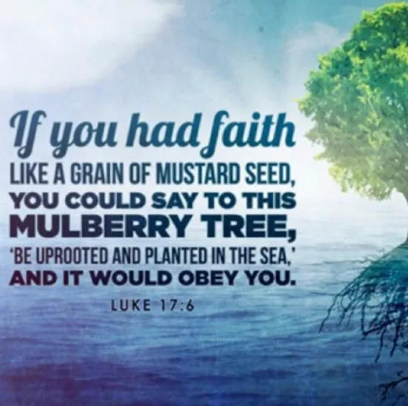

We began the week trying to complete some impossible challenges! Can you touch your elbow with your nose? Can you say the word ‘peas’ without moving your lips?
It would have been amazing if anyone had managed to do either of the challenges as they are both considered impossible! We listened to the Gospel where Jesus’ disciples want to do amazing and impossible things. With just a little faith they could do things that would usually seem impossible - but nothing is impossible for God. God always answers our prayers, but not always in the way we expect.

What Has Been Happening
In Class This Week?

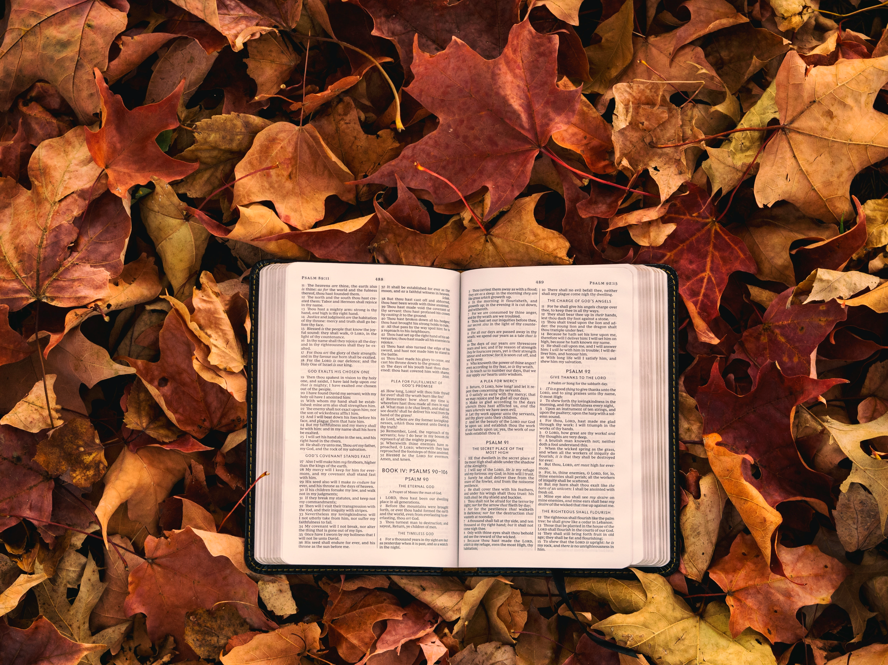


This week, nursery have been discussing how we can be a kind friend. We all said how we can be kind to each other then we made kindness flowers to remind ourselves how we can be kind. The children have been trying very hard to share and care for their friends when they are playing and watching out for their friends in the classroom and outside.
This week reception have been celebrating Black History Month. We learnt all about the wonderful
Mary Seacole and how much she helped people during the Crimea War. She was an amazing woman and we are all very inspired by her to do great things in our lives ahead.

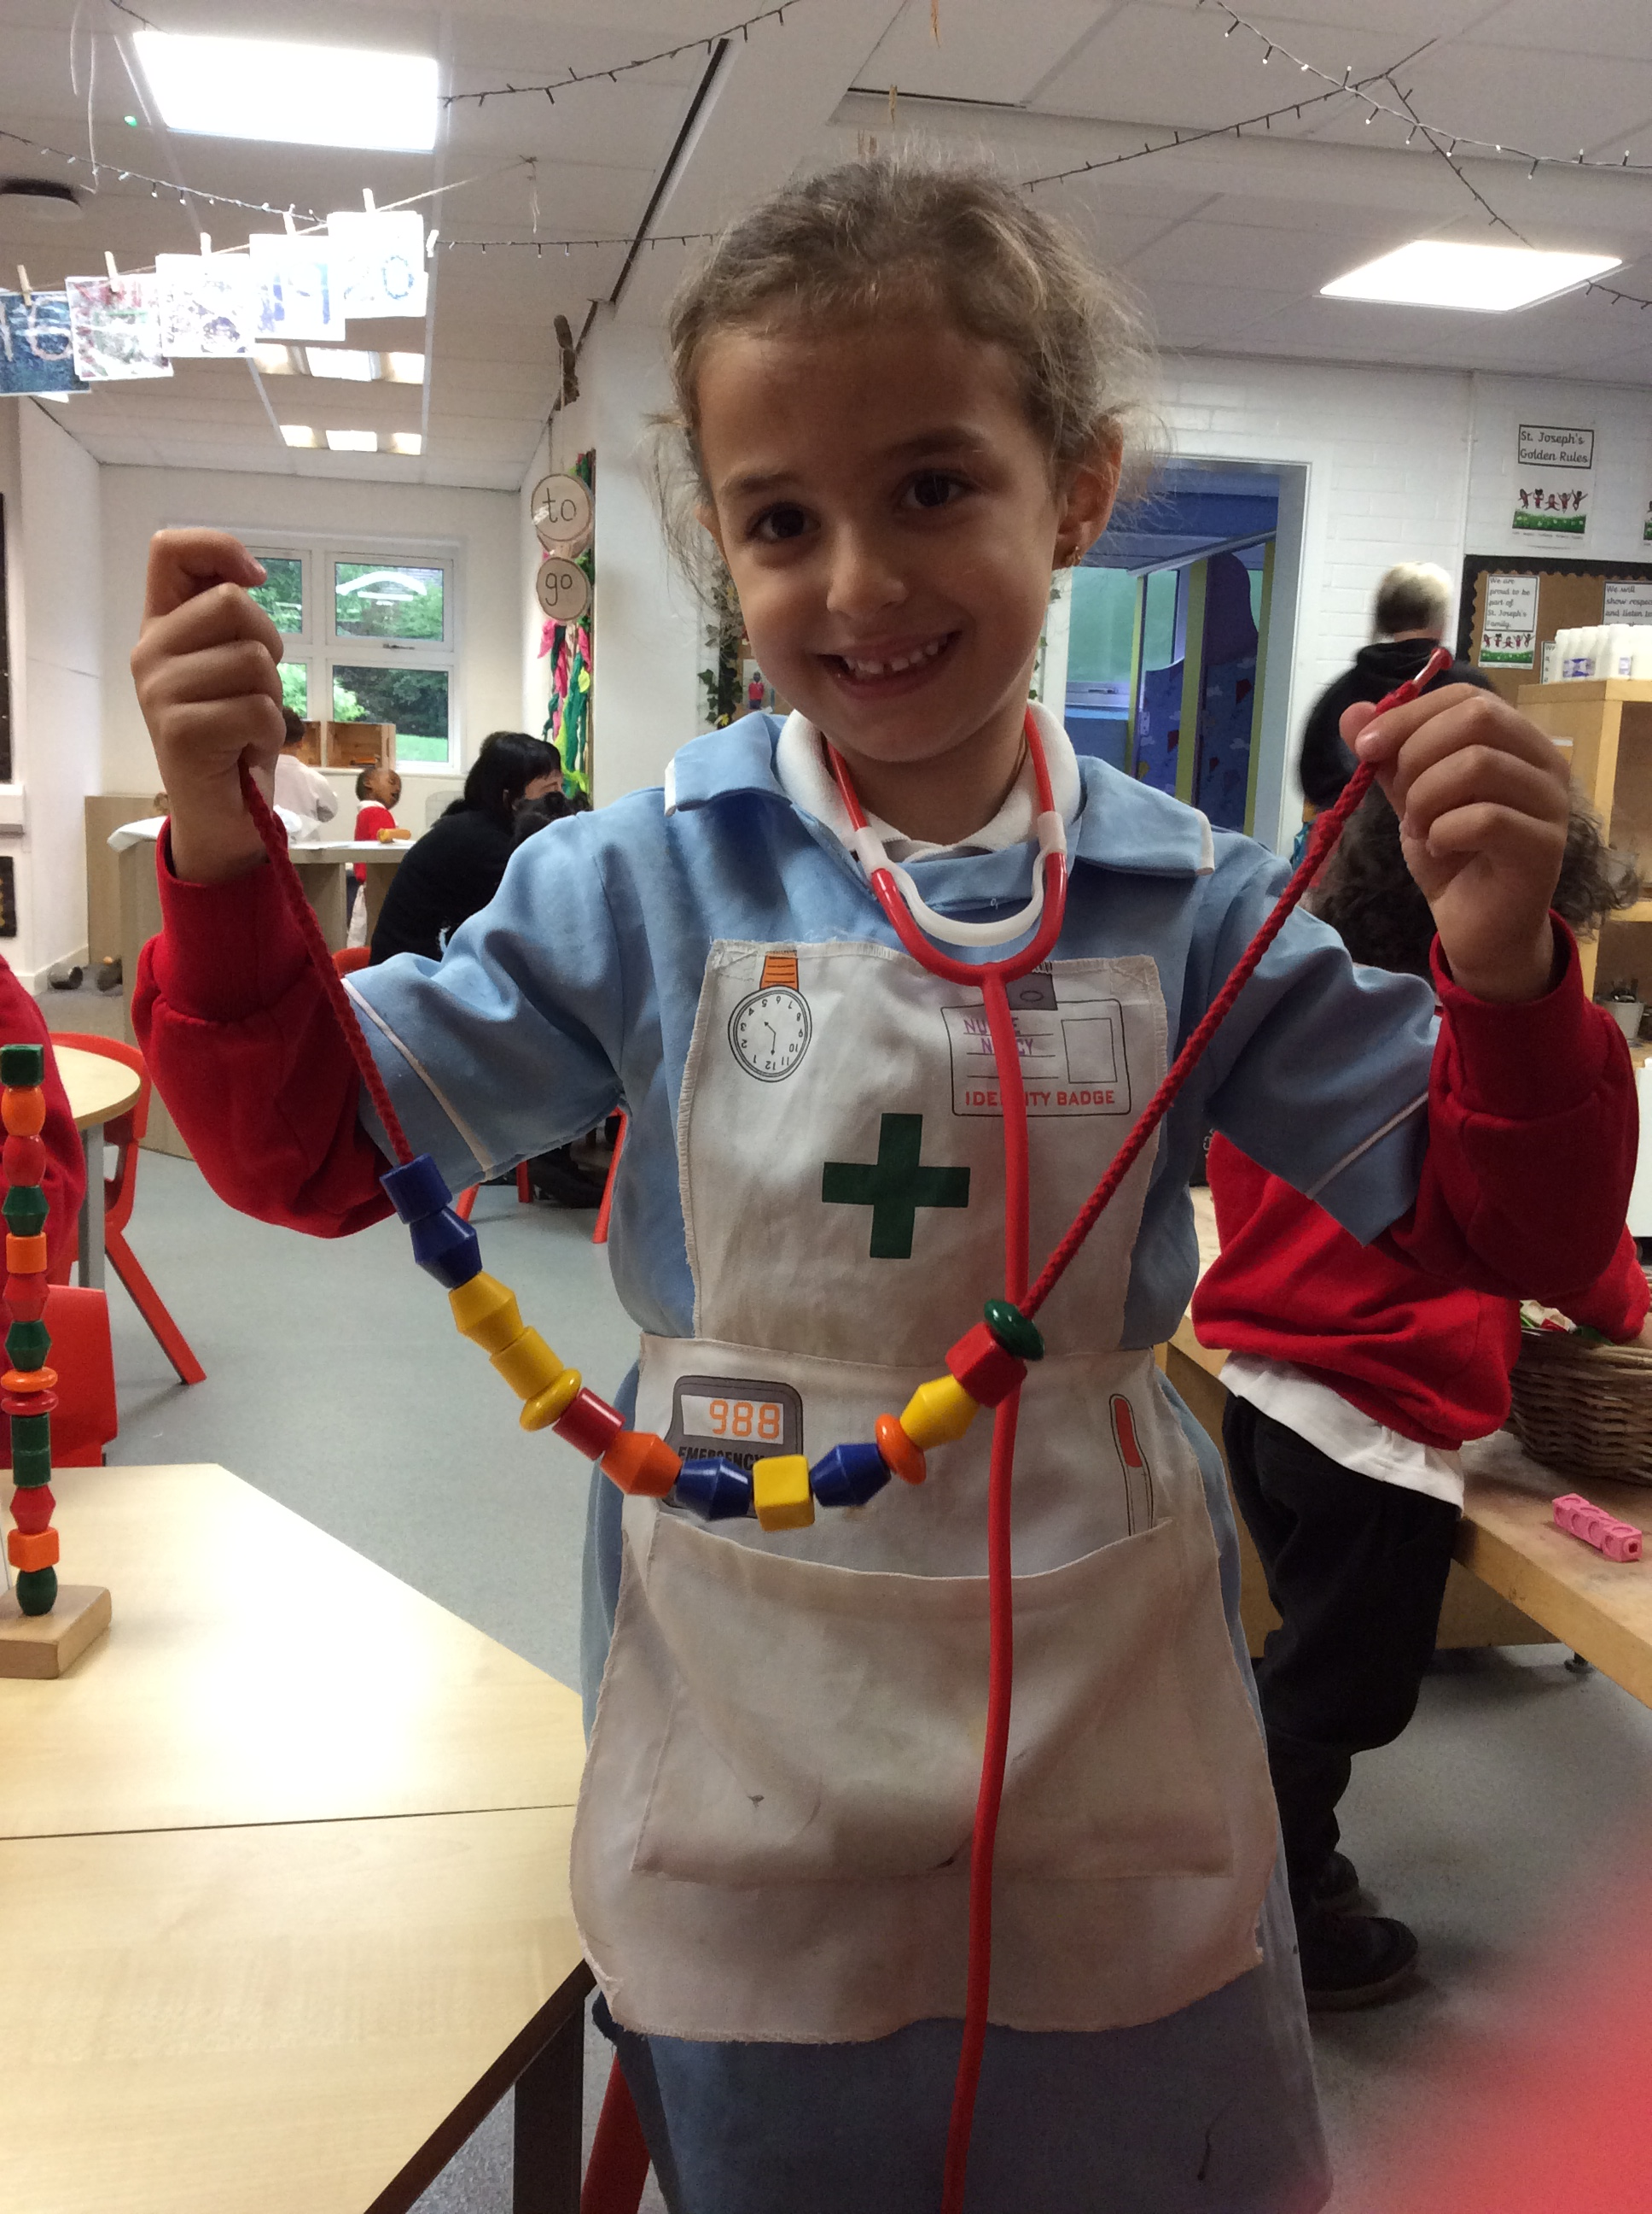
Reception

Nursery

You probably already heard, but this week, an alien crashed landed at our school! Her name is Beegu. We will be reading Alexis Deacon's story Beegu
We have used point of view to discuss how Beegu might be feeling. She has been very scared, but our class is making her feel nice and welcome.
In science, we got to try all the different parts of a plant. We are carrots for the root, celery for the stem, lettuce for the leaves, and blueberries for the fruit.
In geography, we modelled our community. We made our school, police stations, Sainsburys, Tescos, bus stations, and much much more. Next week we will be discussing jobs in our community and adding people to our buildings.

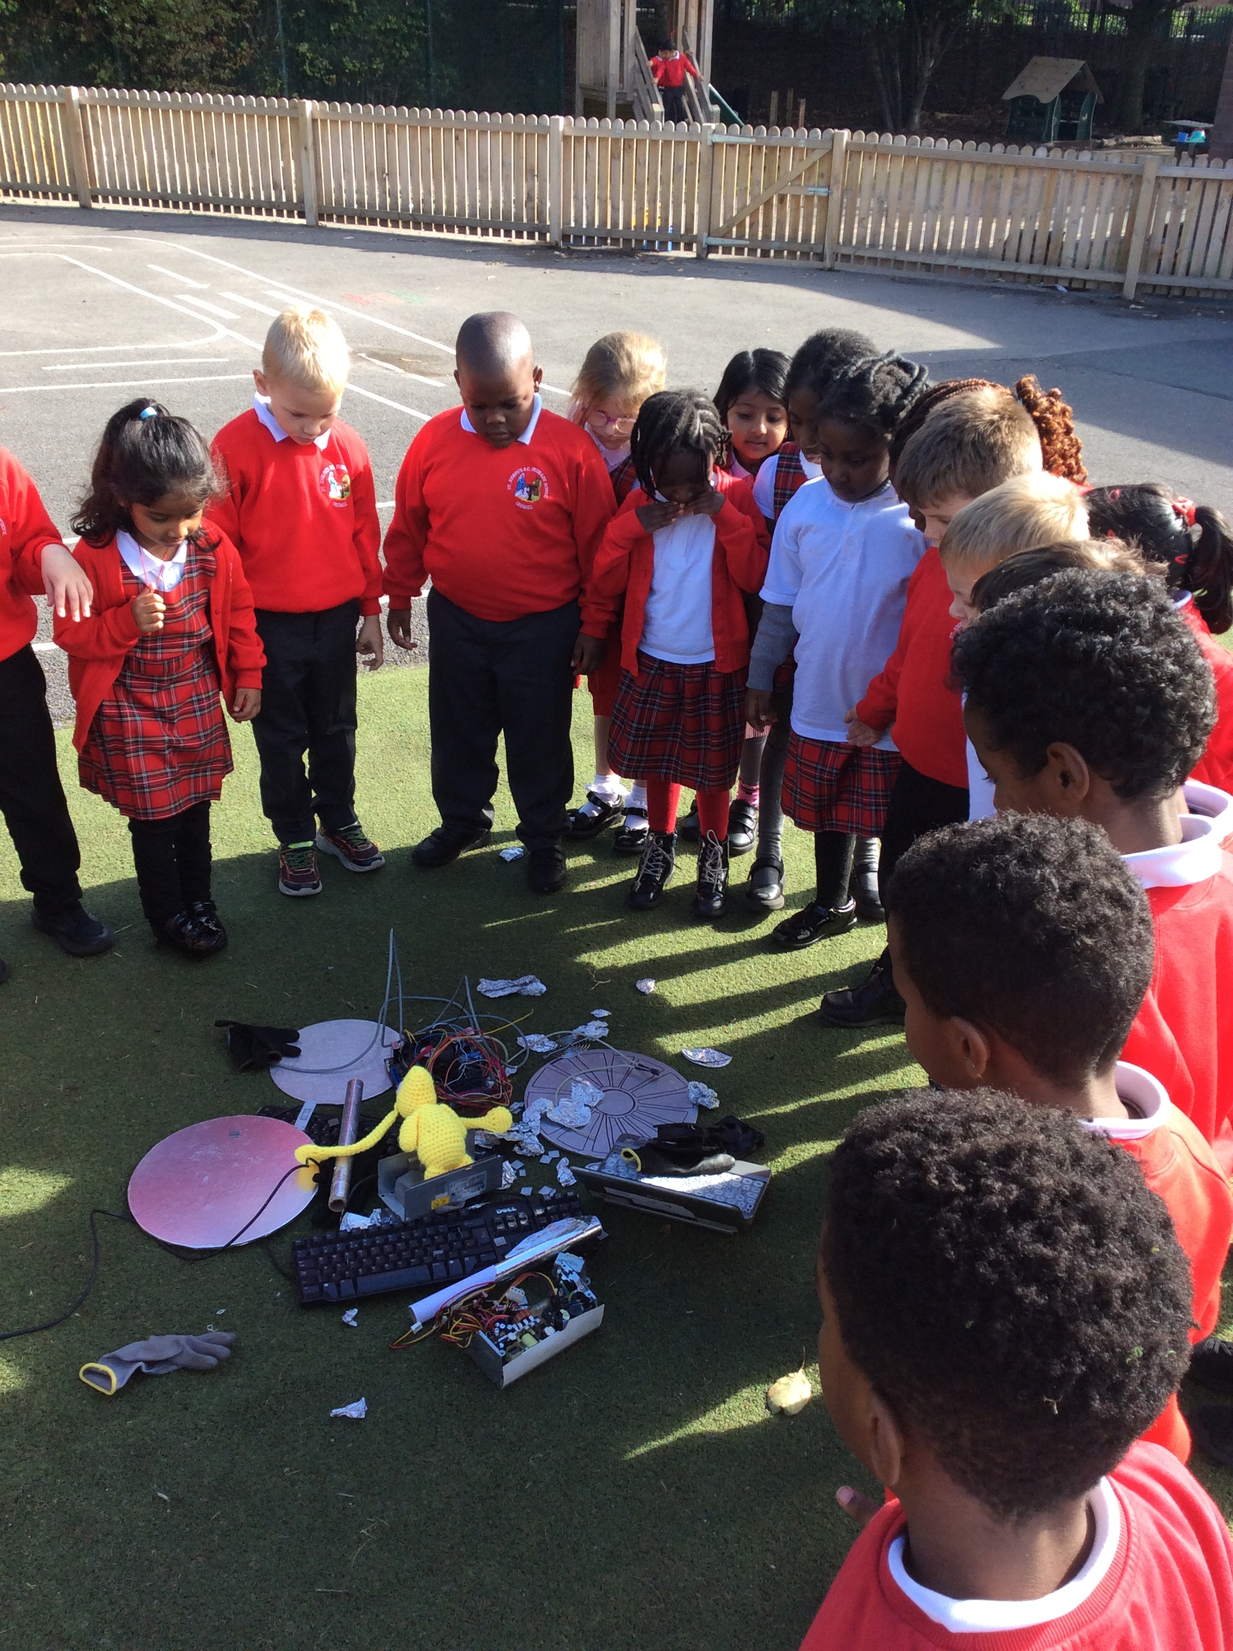

Year 1

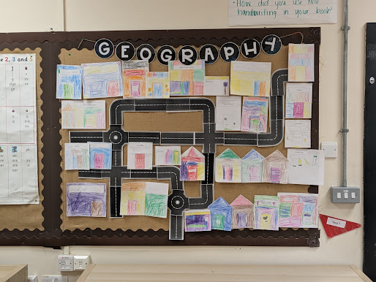

Year 2

Year 2 have been learning about our environment and looking at the important work Sir David Attenborough has done throughout his life this week. We started off by watching some Planet Earth clips of Sir David with different animals. We conducted some research about his life and all of his achievements and put this together to complete our own fact files. This is all going to be important for us moving on and learning how to protect our environments. In maths we have been adding 3 addends and using our maths knowledge to help us be more efficient when adding numbers. In Geography we have been looking at hot and cold climates in different continents around the world.

Year 3 have been practising hard for their assembly all about Black History month, and learnt lots about some significant figures in Black history. We have been exploring further into Europe in Geography and focusing on a city in Italy and how it is different from Manchester. It’s a ten from us, as we use groups of 10 to explore making 100 and beyond, using our knowledge of times tables to understand 3-digit numbers. As we finalise our poems about the monster in The Iron Man, we are excited to begin looking at a new book soon. Keep doing us proud year 3.
In English, the children prepared to write a vivid setting description of The Grotto of Razvani, carefully gathering descriptive details from the text to help them capture the atmosphere, appearance, and mood of the scene.
In Maths, they practised using a range of efficient strategies to solve addition and subtraction problems and explored how to measure and compare length, volume, mass, and capacity through practical activities.
In RE, the children continued to study Jesus’ family tree, learning more about Solomon and Joseph and their important roles within Biblical history.
In Geography, they investigated how earthquakes occur, examined the movement of tectonic plates, and used world maps to locate some of the strongest earthquakes ever recorded.
In Art, the children experimented with colour blending, line, and shading techniques to create dynamic and expressive tornado-themed artwork.

Year 3

Year 4

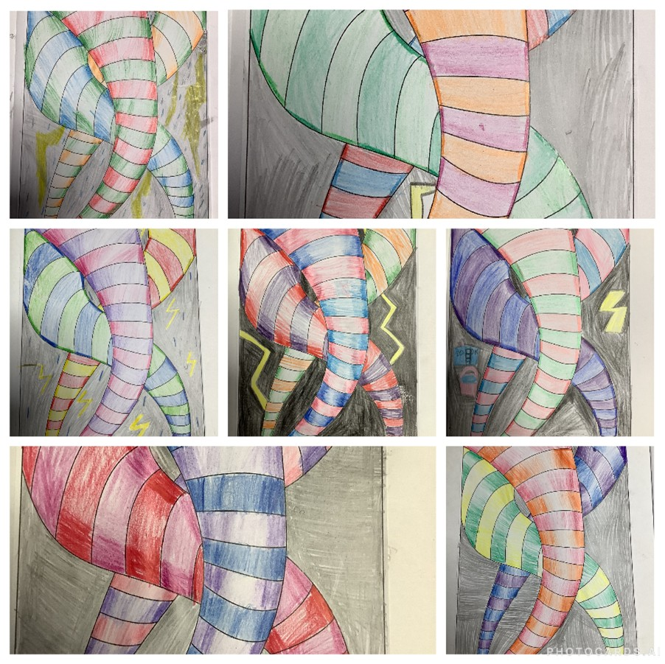

It has been another lovely week in Year 5 this week. The children have been working hard to solve different maths problems and they have been improving their spelling and grammar skills day in day out. In RE this week, we reflected upon how it takes courage to adopt qualities for the service of others and what attributes you would need to be a good role model. The pupils are really mastering their haka dancing in PE and have been learning all about how we use different computer systems in the modern world. Investigating water resistance in science was exciting as the children tried to see which play dough shapes were the most streamlined and travelled fastest in water. Our journey with Beowulf has brought us to face the beastly dragon and the children have continued writing their fantastic biographies of the mighty Prince. This tied in well with our Vikings topic where we found out just how King Alfred fought many battles but eventually managed to find peace with those who invaded. As always, it has been amazing to hear the beautiful singing voices and instrumentation of Year 5 in music. They are such a talented bunch.

Year 5

Another week in Year 6 has come to an end! The children are still working incredibly hard in all lessons, which is great to see. In Maths, they have been looking at addition and how to use known facts to make their lives a little bit easier when adding up. In English, they are writing a survival guide for being stranded on a desert island! In Science, they have been classifying plants this week and were all very interested to find out that leaves sometimes have lobes! Please remember to keep supporting your child with their reading and online learning - we have a spelling test every Friday and so far, the scores have been excellent.

Year 6

THIS WEEKS ATTENDANCE
Nursery | 91.2% | Reception | 86%
Year 1 | 96.9% | Year 2 | 96.2%
Year 3 | 94.3% | Year 4 | 90%
Year 5 | 96.3% | Year 6 | 97.5%
 | School Total | 93.6%

Happy Birthday To…

Khadija

Grace

Harper

WORK OF THE WEEK
 |  | Reception | Aniebet
Year 1 | Esther | Year 2 | Henry | Year 3 | Arisha
Year 4 | Deakan | Year 5 | Kobi | Year 6 | Leisha

STAR OF THE WEEK
 |  | Reception | Lucas  RESILIENCE
Year 1 | Peculiar  RESPECT | Year 2 | Lauren  Empathy | Year 3 | Dominika  RESPECT
Year 4 | Lydia  RESPECT | Year 5 | Gillian  RESILIENCE | Year 6 | Eleojo  Faith



Dates to Remember

Date | Event
Monday 13th October 2025 | School photographs (individual and siblings)  KS1 Phonics and reading meeting - 3pm - School hall
Wednesday 15th October 2025 | Macmillan coffee afternoon 3pm
Tuesday 21st October | EYFS maths workshop - 3pm – Reception classroom
Thursday 23rd October | KS1 maths workshop - 3pm – Year 2 classroom
Friday 24th October 2025 | School Closes for Half Term Break
Monday 4th November | School Opens for the Autumn 2 Half Term

